The Spring Web MVC framework provides a model-view-controller architecture and ready components that can be used to develop flexible and loosely coupled web applications. The MVC pattern results in separating the different aspects of the application (input logic, business logic, and UI logic), while providing a loose coupling between these elements.
- The Model encapsulates the application data and in general, they will consist of POJO.
- The View is responsible for rendering the model data and in general, it generates HTML output that the client's browser can interpret.
- The Controller is responsible for processing User Requests and Building Appropriate Model and passes it to the view for rendering.
- The DispatcherServlet
The Spring Web model-view-controller (MVC) framework is designed around a DispatcherServlet that handles all the HTTP requests and responses. The request processing workflow of the Spring Web MVC DispatcherServlet is shown in the following illustration.
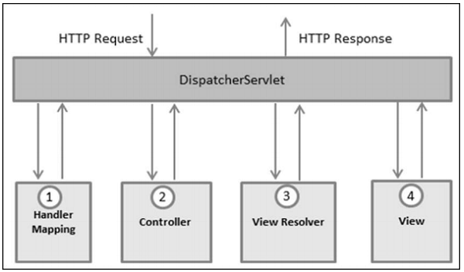
Following is the sequence of events corresponding to an incoming HTTP request to DispatcherServlet −
- After receiving an HTTP request, DispatcherServlet consults the HandlerMapping to call the appropriate Controller.
- The Controller takes the request and calls the appropriate service methods based on used GET or POST method. The service method will set model data based on defined business logic and returns view name to the DispatcherServlet.
- The DispatcherServlet will take help from ViewResolver to pick up the defined view for the request.
- Once view is finalized, The DispatcherServlet passes the model data to the view, which is finally rendered, on the browsers.
All the above-mentioned components, i.e. HandlerMapping, Controller and ViewResolver are parts of WebApplicationContext, which is an extension of the plain ApplicationContext with some extra features necessary for web applications.

Required Configuration
We need to map requests that you want the DispatcherServlet to handle, by using a URL mapping in the web.xml file. The following is an example to show declaration and mapping for HelloWeb DispatcherServlet −
<web-app id = "WebApp_ID" version = "2.4"
xmlns = "http://java.sun.com/xml/ns/j2ee"
xmlns:xsi = "http://www.w3.org/2001/XMLSchema-instance"
xsi:schemaLocation = "http://java.sun.com/xml/ns/j2ee
http://java.sun.com/xml/ns/j2ee/web-app_2_4.xsd">
<display-name>Spring MVC Application</display-name>
<servlet>
<servlet-name>HelloWeb</servlet-name>
<servlet-class>
org.springframework.web.servlet.DispatcherServlet
</servlet-class>
<load-on-startup>1</load-on-startup>
</servlet>
<servlet-mapping>
<servlet-name>HelloWeb</servlet-name>
<url-pattern>*.jsp</url-pattern>
</servlet-mapping>
</web-app>
The web.xml file will be kept in the WebContent/WEB-INF directory of your web application. Upon initialization of the HelloWeb DispatcherServlet, the framework will try to load the application context from a file named [servlet-name]-servlet.xml located in the application's WebContent/WEB-INF directory. In this case, our file will be HelloWeb-servlet.xml.
Next, the <servlet-mapping> tag indicates which URLs will be handled by which DispatcherServlet. Here, all the HTTP requests ending with .jsp will be handled by the HelloWeb DispatcherServlet.
If you do not want to go with the default filename as [servlet-name]-servlet.xml and default location as WebContent/WEB-INF, you can customize this file name and location by adding the servlet listener ContextLoaderListener in your web.xml file as follows −
<web-app...>
<!-------- DispatcherServlet definition goes here----->
<context-param>
<param-name>contextConfigLocation</param-name>
<param-value>/WEB-INF/HelloWeb-servlet.xml</param-value>
</context-param>
<listener>
<listener-class>
org.springframework.web.context.ContextLoaderListener
</listener-class>
</listener>
</web-app>
Now, let us check the required configuration for HelloWeb-servlet.xml file, placed in your web application's WebContent/WEB-INF directory.
<beans xmlns = "http://www.springframework.org/schema/beans"
xmlns:context = "http://www.springframework.org/schema/context"
xmlns:xsi = "http://www.w3.org/2001/XMLSchema-instance"
xsi:schemaLocation = "
http://www.springframework.org/schema/beans
http://www.springframework.org/schema/beans/spring-beans-3.0.xsd
http://www.springframework.org/schema/context
http://www.springframework.org/schema/context/spring-context-3.0.xsd">
<context:component-scan base-package = "com.tutorialspoint" />
<bean class = "org.springframework.web.servlet.view.InternalResourceViewResolver">
<property name = "prefix" value = "/WEB-INF/jsp/" />
<property name = "suffix" value = ".jsp" />
</bean>
</beans>
Following are some important points about HelloWeb-servlet.xml file −
- The [servlet-name]-servlet.xml file will be used to create the beans defined, overriding the definitions of any beans defined with the same name in the global scope.
- The <context:component-scan...> tag will be used to activate the Spring MVC annotation scanning capability, which allows to make use of annotations like @Controller and @RequestMapping, etc.
- The InternalResourceViewResolver will have rules defined to resolve the view names. As per the above-defined rule, a logical view named hello is delegated to a view implementation located at /WEB-INF/jsp/hello.jsp.
Let us now understand how to create the actual components i.e., Controller, Model and View.

Defining a Controller
The DispatcherServlet delegates the request to the controllers to execute the functionality specific to it. The @Controller annotation indicates that a particular class serves the role of a controller. The @RequestMappingannotation is used to map a URL to either an entire class or a particular handler method.
@Controller
@RequestMapping("/hello")
public class HelloController{
@RequestMapping(method = RequestMethod.GET)
public String printHello(ModelMap model) {
model.addAttribute("message", "Hello Spring MVC Framework!");
return "hello";
}
}
The @Controller annotation defines the class as a Spring MVC controller. Here, the first usage of @RequestMapping indicates that all handling methods on this controller are relative to the /hello path.
The next annotation @RequestMapping (method = RequestMethod.GET)is used to declare the printHello() method as the controller's default service method to handle HTTP GET request. We can define another method to handle any POST request at the same URL.
We can also write the above controller in another form, where we can add additional attributes in the @RequestMapping as follows −
@Controller
public class HelloController{
@RequestMapping(value = "/hello", method = RequestMethod.GET)
public String printHello(ModelMap model) {
model.addAttribute("message", "Hello Spring MVC Framework!");
return "hello";
}
}
The value attribute indicates the URL to which the handler method is mapped and the method attribute defines the service method to handle the HTTP GET request.
Following are some important points to be noted regarding the controller defined above −
- You will define the required business logic inside a service method. You can call another method inside this method as per the requirement.
- Based on the business logic defined, you will create a model within this method. You can set different model attributes and these attributes will be accessed by the view to present the result. This example creates a model with its attribute "message".
- A defined service method can return a String, which contains the name of the view to be used to render the model. This example returns "hello" as the logical view name.

Creating JSP Views
Spring MVC supports many types of views for different presentation technologies. These include - JSPs, HTML, PDF, Excel Worksheets, XML, Velocity Templates, XSLT, JSON, Atom and RSS feeds, JasperReports, etc. However, the most common ones are the JSP templates written with JSTL. So, let us write a simple hello view in /WEB-INF/hello/hello.jsp −
<html>
<head>
<title>Hello Spring MVC</title>
</head>
<body>
<h2>${message}</h2>
</body>
</html>
Here ${message} Here is the attribute, which we have setup inside the Controller. You can have multiple attributes to be displayed inside your view.
Complete Example:
- Project Structure:
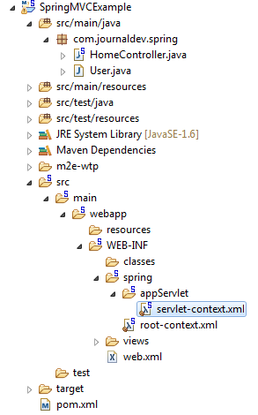

- Pom.xml:
<?xml version="1.0" encoding="UTF-8"?>
<project xmlns="http://maven.apache.org/POM/4.0.0" xmlns:xsi="http://www.w3.org/2001/XMLSchema-instance"
xsi:schemaLocation="http://maven.apache.org/POM/4.0.0 http://maven.apache.org/maven-v4_0_0.xsd">
<modelVersion>4.0.0</modelVersion>
<groupId>com.journaldev</groupId>
<artifactId>SpringMVCExample</artifactId>
<name>SpringMVCExample</name>
<packaging>war</packaging>
<version>1.0.0-BUILD-SNAPSHOT</version>
<properties>
<java-version>1.8</java-version>
<org.springframework-version>4.0.0.RELEASE</org.springframework-version>
<org.aspectj-version>1.7.4</org.aspectj-version>
<org.slf4j-version>1.7.5</org.slf4j-version>
</properties>
<dependencies>
<!-- Spring -->
<dependency>
<groupId>org.springframework</groupId>
<artifactId>spring-context</artifactId>
<version>${org.springframework-version}</version>
<exclusions>
<!-- Exclude Commons Logging in favor of SLF4j -->
<exclusion>
<groupId>commons-logging</groupId>
<artifactId>commons-logging</artifactId>
</exclusion>
</exclusions>
</dependency>
<dependency>
<groupId>org.springframework</groupId>
<artifactId>spring-webmvc</artifactId>
<version>${org.springframework-version}</version>
</dependency>

<!-- AspectJ -->
<dependency>
<groupId>org.aspectj</groupId>
<artifactId>aspectjrt</artifactId>
<version>${org.aspectj-version}</version>
</dependency>

<!-- Logging -->
<dependency>
<groupId>org.slf4j</groupId>
<artifactId>slf4j-api</artifactId>
<version>${org.slf4j-version}</version>
</dependency>
<dependency>
<groupId>org.slf4j</groupId>
<artifactId>jcl-over-slf4j</artifactId>
<version>${org.slf4j-version}</version>
<scope>runtime</scope>
</dependency>
<dependency>
<groupId>org.slf4j</groupId>
<artifactId>slf4j-log4j12</artifactId>
<version>${org.slf4j-version}</version>
<scope>runtime</scope>
</dependency>
<dependency>
<groupId>log4j</groupId>
<artifactId>log4j</artifactId>
<version>1.2.15</version>
<exclusions>
<exclusion>
<groupId>javax.mail</groupId>
<artifactId>mail</artifactId>
</exclusion>
<exclusion>
<groupId>javax.jms</groupId>
<artifactId>jms</artifactId>
</exclusion>
<exclusion>
<groupId>com.sun.jdmk</groupId>
<artifactId>jmxtools</artifactId>
</exclusion>
<exclusion>
<groupId>com.sun.jmx</groupId>
<artifactId>jmxri</artifactId>
</exclusion>
</exclusions>
<scope>runtime</scope>
</dependency>

<!-- @Inject -->
<dependency>
<groupId>javax.inject</groupId>
<artifactId>javax.inject</artifactId>
<version>1</version>
</dependency>

<!-- Servlet -->
<dependency>
<groupId>javax.servlet</groupId>
<artifactId>servlet-api</artifactId>
<version>2.5</version>
<scope>provided</scope>
</dependency>
<dependency>
<groupId>javax.servlet.jsp</groupId>
<artifactId>jsp-api</artifactId>
<version>2.1</version>
<scope>provided</scope>
</dependency>
<dependency>
<groupId>javax.servlet</groupId>
<artifactId>jstl</artifactId>
<version>1.2</version>
</dependency>

<!-- Test -->
<dependency>
<groupId>junit</groupId>
<artifactId>junit</artifactId>
<version>4.7</version>
<scope>test</scope>
</dependency>
</dependencies>
<build>
<finalName>SpringMVCExample</finalName>
<plugins>
<plugin>
<artifactId>maven-eclipse-plugin</artifactId>
<version>2.9</version>
<configuration>
<additionalProjectnatures>
<projectnature>org.springframework.ide.eclipse.core.springnature</projectnature>
</additionalProjectnatures>
<additionalBuildcommands>
<buildcommand>org.springframework.ide.eclipse.core.springbuilder</buildcommand>
</additionalBuildcommands>
<downloadSources>true</downloadSources>
<downloadJavadocs>true</downloadJavadocs>
</configuration>
</plugin>
<plugin>
<groupId>org.apache.maven.plugins</groupId>
<artifactId>maven-compiler-plugin</artifactId>
<version>2.5.1</version>
<configuration>
<source>1.6</source>
<target>1.6</target>
<compilerArgument>-Xlint:all</compilerArgument>
<showWarnings>true</showWarnings>
<showDeprecation>true</showDeprecation>
</configuration>
</plugin>
<plugin>
<groupId>org.codehaus.mojo</groupId>
<artifactId>exec-maven-plugin</artifactId>
<version>1.2.1</version>
<configuration>
<mainClass>org.test.int1.Main</mainClass>
</configuration>
</plugin>
</plugins>
</build>
</project>
- Web.xml:
<?xml version="1.0" encoding="UTF-8"?>
<web-app version="2.5" xmlns="http://java.sun.com/xml/ns/javaee"
xmlns:xsi="http://www.w3.org/2001/XMLSchema-instance"
xsi:schemaLocation="http://java.sun.com/xml/ns/javaee http://java.sun.com/xml/ns/javaee/web-app_2_5.xsd">

<!-- The definition of the Root Spring Container shared by all Servlets
and Filters -->
<context-param>
<param-name>contextConfigLocation</param-name>
<param-value>/WEB-INF/spring/root-context.xml</param-value>
</context-param>

<!-- Creates the Spring Container shared by all Servlets and Filters -->
<listener>
<listener-class>org.springframework.web.context.ContextLoaderListener</listener-class>
</listener>

<!-- Processes application requests -->
<servlet>
<servlet-name>appServlet</servlet-name>
<servlet-class>org.springframework.web.servlet.DispatcherServlet</servlet-class>
<init-param>
<param-name>contextConfigLocation</param-name>
<param-value>/WEB-INF/spring/appServlet/servlet-context.xml</param-value>
</init-param>
<load-on-startup>1</load-on-startup>
</servlet>

<servlet-mapping>
<servlet-name>appServlet</servlet-name>
<url-pattern>/</url-pattern>
</servlet-mapping>

</web-app>

- Servlet-context.xml:
<?xml version="1.0" encoding="UTF-8"?>
<beans:beans xmlns="http://www.springframework.org/schema/mvc"
xmlns:xsi="http://www.w3.org/2001/XMLSchema-instance"
xmlns:beans="http://www.springframework.org/schema/beans"
xmlns:context="http://www.springframework.org/schema/context"
xsi:schemaLocation="http://www.springframework.org/schema/mvc http://www.springframework.org/schema/mvc/spring-mvc.xsd
http://www.springframework.org/schema/beans http://www.springframework.org/schema/beans/spring-beans.xsd
http://www.springframework.org/schema/context http://www.springframework.org/schema/context/spring-context.xsd">

<!-- DispatcherServlet Context: defines this servlet's request-processing infrastructure -->

<!-- Enables the Spring MVC @Controller programming model -->
<annotation-driven />

<!-- Handles HTTP GET requests for /resources/** by efficiently serving up static resources in the ${webappRoot}/resources directory -->
<resources mapping="/resources/**" location="/resources/" />

<!-- Resolves views selected for rendering by @Controllers to .jsp resources in the /WEB-INF/views directory -->
<beans:bean class="org.springframework.web.servlet.view.InternalResourceViewResolver">
<beans:property name="prefix" value="/WEB-INF/views/" />
<beans:property name="suffix" value=".jsp" />
</beans:bean>

<context:component-scan base-package="com.journaldev.spring" />

</beans:beans>

- HomeController.java:
package com.journaldev.spring;
import java.text.DateFormat;
import java.util.Date;
import java.util.Locale;
import org.slf4j.Logger;
import org.slf4j.LoggerFactory;
import org.springframework.stereotype.Controller;
import org.springframework.ui.Model;
import org.springframework.validation.annotation.Validated;
import org.springframework.web.bind.annotation.RequestMapping;
import org.springframework.web.bind.annotation.RequestMethod;

/**
* Handles requests for the application home page.
*/
@Controller
public class HomeController {
private static final Logger logger = LoggerFactory.getLogger(HomeController.class);
/**
* Simply selects the home view to render by returning its name.
*/
@RequestMapping(value = "/", method = RequestMethod.GET)
public String home(Locale locale, Model model) {
logger.info("Welcome home! The client locale is {}.", locale);
Date date = new Date();
DateFormat dateFormat = DateFormat.getDateTimeInstance(DateFormat.LONG, DateFormat.LONG, locale);
String formattedDate = dateFormat.format(date);
model.addAttribute("serverTime", formattedDate );
return "home";
}
}
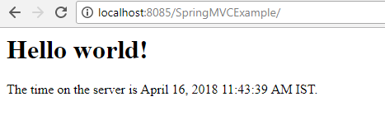

Spring MVC - Form Handling
- Project Structure:
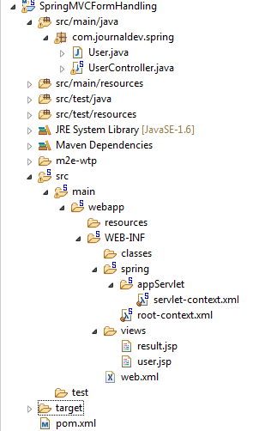
Pom.xml,web.xml and servlet-context.xml are same as SpringMVCExample above
- User.java:
package com.journaldev.spring;

public class User {

private String username;
private String password;
private String address;
private boolean receivePaper;
private String[] favoriteFrameworks;
private String gender;
private String favoriteNumber;
private String country;
private String[] skills;

public String getUsername() {
return username;
}

public void setUsername(String username) {
this.username = username;
}

public String getPassword() {
return password;
}

public void setPassword(String password) {
this.password = password;
}

public String getAddress() {
return address;
}

public void setAddress(String address) {
this.address = address;
}

public boolean isReceivePaper() {
return receivePaper;
}

public void setReceivePaper(boolean receivePaper) {
this.receivePaper = receivePaper;
}

public String[] getFavoriteFrameworks() {
return favoriteFrameworks;
}

public void setFavoriteFrameworks(String[] favoriteFrameworks) {
this.favoriteFrameworks = favoriteFrameworks;
}

public String getGender() {
return gender;
}

public void setGender(String gender) {
this.gender = gender;
}

public String getFavoriteNumber() {
return favoriteNumber;
}

public void setFavoriteNumber(String favoriteNumber) {
this.favoriteNumber = favoriteNumber;
}

public String getCountry() {
return country;
}

public void setCountry(String country) {
this.country = country;
}

public String[] getSkills() {
return skills;
}

public void setSkills(String[] skills) {
this.skills = skills;
}
}
- UserController.java:
package com.journaldev.spring;

import java.util.ArrayList;
import java.util.HashMap;
import java.util.List;
import java.util.Map;

import org.springframework.stereotype.Controller;
import org.springframework.ui.ModelMap;
import org.springframework.web.bind.annotation.ModelAttribute;
import org.springframework.web.bind.annotation.RequestMapping;
import org.springframework.web.bind.annotation.RequestMethod;
import org.springframework.web.servlet.ModelAndView;

@Controller
public class UserController {

@RequestMapping(value = "/user", method = RequestMethod.GET)
public ModelAndView user() {
User user = new User();
user.setFavoriteFrameworks((new String []{"Spring MVC","Struts 2"}));
user.setGender("M");
ModelAndView modelAndView = new ModelAndView("user", "command", user);
return modelAndView;
}

@RequestMapping(value = "/addUser", method = RequestMethod.POST)
public String addUser(@ModelAttribute("SpringWeb")User user,
ModelMap model) {
model.addAttribute("username", user.getUsername());
model.addAttribute("password", user.getPassword());
model.addAttribute("address", user.getAddress());
model.addAttribute("receivePaper", user.isReceivePaper());
model.addAttribute("favoriteFrameworks", user.getFavoriteFrameworks());
model.addAttribute("gender", user.getGender());
model.addAttribute("favoriteNumber", user.getFavoriteNumber());
model.addAttribute("country", user.getCountry());
model.addAttribute("skills", user.getSkills());
return "result";
}

@ModelAttribute("webFrameworkList")
public List<String> getWebFrameworkList() {
List<String> webFrameworkList = new ArrayList<String>();
webFrameworkList.add("Spring MVC");
webFrameworkList.add("Struts 1");
webFrameworkList.add("Struts 2");
webFrameworkList.add("Apache Wicket");
return webFrameworkList;
}

@ModelAttribute("numbersList")
public List<String> getNumbersList() {
List<String> numbersList = new ArrayList<String>();
numbersList.add("1");
numbersList.add("2");
numbersList.add("3");
numbersList.add("4");
return numbersList;
}

@ModelAttribute("countryList")
public Map<String, String> getCountryList() {
Map<String, String> countryList = new HashMap<String, String>();
countryList.put("US", "United States");
countryList.put("CH", "China");
countryList.put("SG", "Singapore");
countryList.put("MY", "Malaysia");
return countryList;
}

@ModelAttribute("skillsList")
public Map<String, String> getSkillsList() {
Map<String, String> skillList = new HashMap<String, String>();
skillList.put("Hibernate", "Hibernate");
skillList.put("Spring", "Spring");
skillList.put("Apache Wicket", "Apache Wicket");
skillList.put("Struts", "Struts");
return skillList;
}
}

- user.jsp:
<%@taglib uri = "http://www.springframework.org/tags/form" prefix = "form"%>
<html>
<head>
<title>Spring MVC Form Handling</title>
</head>
<body>

<h2>User Information</h2>
<form:form method = "POST" action = "/SpringMVCFormHandling/addUser">
<table>
<tr>
<td><form:label path = "username">User Name</form:label></td>
<td><form:input path = "username" /></td>
</tr>
<tr>
<td><form:label path = "password">Age</form:label></td>
<td><form:password path = "password" /></td>
</tr>
<tr>
<td><form:label path = "address">Address</form:label></td>
<td><form:textarea path = "address" rows = "5" cols = "30" /></td>
</tr>
<tr>
<td><form:label path = "receivePaper">Subscribe Newsletter</form:label></td>
<td><form:checkbox path = "receivePaper" /></td>
</tr>
<tr>
<td><form:label path = "favoriteFrameworks">Favorite Web Frameworks</form:label></td>
<td><form:checkboxes items = "${webFrameworkList}" path = "favoriteFrameworks" /></td>
</tr>
<tr>
<td><form:label path = "gender">Gender</form:label></td>
<td>
<form:radiobutton path = "gender" value = "M" label = "Male" />
<form:radiobutton path = "gender" value = "F" label = "Female" />
</td>
</tr>
<tr>
<td><form:label path = "favoriteNumber">Favorite Number</form:label></td>
<td>
<form:radiobuttons path = "favoriteNumber" items = "${numbersList}" />
</td>
</tr>
<tr>
<td><form:label path = "country">Country</form:label></td>
<td>
<form:select path = "country">
<form:option value = "NONE" label = "Select"/>
<form:options items = "${countryList}" />
</form:select>
</td>
</tr>
<tr>
<td><form:label path = "skills">Skills</form:label></td>
<td>
<form:select path = "skills" items = "${skillsList}"
multiple = "true" />
</td>
</tr>
<tr>
<td colspan = "2">
<input type = "submit" value = "Submit"/>
</td>
</tr>
</table>
</form:form>
</body>
</html>
- Result.jsp:
<%@taglib uri = "http://www.springframework.org/tags/form" prefix = "form"%>
<html>
<head>
<title>Spring MVC Form Handling</title>
</head>
<body>

<h2>Submitted User Information</h2>
<table>
<tr>
<td>Username</td>
<td>${username}</td>
</tr>
<tr>
<td>Password</td>
<td>${password}</td>
</tr>
<tr>
<td>Address</td>
<td>${address}</td>
</tr>
<tr>
<td>Subscribed to Newsletter</td>
<td>${receivePaper}</td>
</tr>
<tr>
<td>Favorite Web Frameworks</td>
<td> <% String[] favoriteFrameworks = (String[])request.getAttribute("favoriteFrameworks");
for(String framework: favoriteFrameworks) {
out.println(framework);
}
%></td>
</tr>
<tr>
<td>Gender</td>
<td>${(gender=="M"? "Male" : "Female")}</td>
</tr>
<tr>
<td>Favourite Number</td>
<td>${favoriteNumber}</td>
</tr>
<tr>
<td>Country</td>
<td>${country}</td>
</tr>
<tr>
<td>Skills</td>
<td> <% String[] skills = (String[])request.getAttribute("skills");
for(String skill: skills) {
out.println(skill);
}
%></td>
</tr>
</table>
</body>
</html>
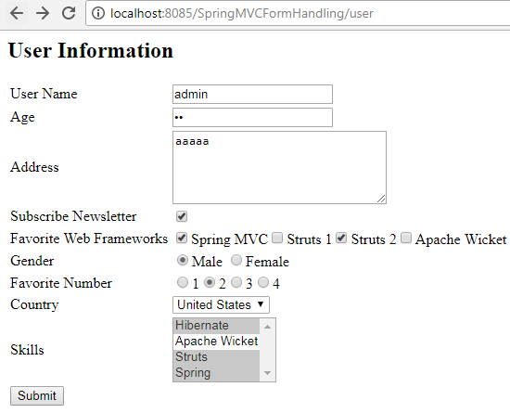
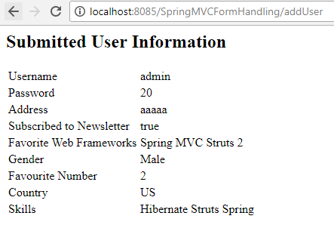

Spring MVC - Form Validator
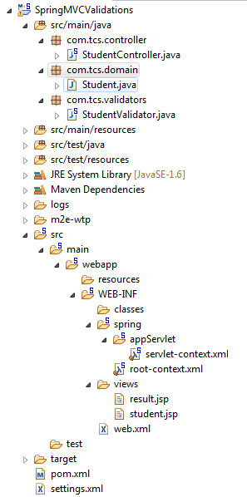
Pom.xml,web.xml and servlet-context.xml are same as SpringMVCExample above
- Student.java:
package com.tcs.domain;

public class Student {
private Integer age;
private String name;
private Integer id;

public void setAge(Integer age) {
this.age = age;
}

public Integer getAge() {
return age;
}

public void setName(String name) {
this.name = name;
}

public String getName() {
return name;
}

public void setId(Integer id) {
this.id = id;
}

public Integer getId() {
return id;
}
}
- StudentValidtor.java:
package com.tcs.validators;
import org.springframework.validation.Errors;
import org.springframework.validation.ValidationUtils;
import org.springframework.validation.Validator;
import com.tcs.domain.Student;

public class StudentValidator implements Validator {
@Override
public boolean supports(Class<?> paramClass) {
return Student.class.equals(paramClass);
}

@Override
public void validate(Object obj, Errors errors) {
ValidationUtils.rejectIfEmptyOrWhitespace(errors, "id", "id.required");
ValidationUtils.rejectIfEmptyOrWhitespace(errors, "name","name.required");
ValidationUtils.rejectIfEmptyOrWhitespace(errors, "age","age.required");
}
}
- StudentController.java:
package com.tcs.controller;
import java.util.Locale;
import org.springframework.beans.factory.annotation.Autowired;
import org.springframework.beans.factory.annotation.Qualifier;
import org.springframework.stereotype.Controller;
import org.springframework.ui.Model;
import org.springframework.validation.BindingResult;
import org.springframework.validation.Validator;
import org.springframework.validation.annotation.Validated;
import org.springframework.web.bind.WebDataBinder;
import org.springframework.web.bind.annotation.InitBinder;
import org.springframework.web.bind.annotation.ModelAttribute;
import org.springframework.web.bind.annotation.RequestMapping;
import org.springframework.web.bind.annotation.RequestMethod;
import com.tcs.domain.Student;

@Controller
public class StudentController {

@Autowired
@Qualifier("studentValidator")
private Validator validator;

@InitBinder
private void initBinder(WebDataBinder binder) {
binder.setValidator(validator);
}

/**
* Simply selects the home view to render by returning its name.
*/
@RequestMapping(value = "/", method = RequestMethod.GET)
public String home(@ModelAttribute("student") Student student,
Locale locale, Model model) {
model.addAttribute("name", new Student());
return "student";
}

@RequestMapping(value = "/student", method = RequestMethod.GET)
public String studentPage(Locale locale, Model model) {
model.addAttribute("name", new Student());
return "student";
}

@RequestMapping(value = "/addStudent", method = RequestMethod.POST)
public String addStudent(@ModelAttribute("student") @Validated Student student,
BindingResult bindingResult, Model model) {
if (bindingResult.hasErrors()) {
return "student";
} else {
model.addAttribute("name", student.getName());
model.addAttribute("age", student.getAge());
model.addAttribute("id", student.getId());
return "result";
}
}
}

- Student.jsp:
<%@ page language="java" contentType="text/html; charset=ISO-8859-1"
pageEncoding="ISO-8859-1"%>
<%@taglib uri="http://www.springframework.org/tags/form" prefix="form"%>
<html>
<head>
<title>Spring MVC Form Validations</title>
<style>
.error {
color: #ff0000;
font-style: italic;
font-weight: bold;
}
</style>
</head>
<body>

<h2>Student Information</h2>
<form:form method="POST" action="/SpringMVCValidations/addStudent"
modelAttribute="student">
<table>
<tr>
<td><form:label path="name">Name</form:label></td>
<td><form:input path="name" /><form:errors path="name" cssClass="error" /></td>
</tr>
<tr>
<td><form:label path="age">Age</form:label></td>
<td><form:input path="age" /><form:errors path="age" cssClass="error" /></td>
</tr>
<tr>
<td><form:label path="id">id</form:label></td>
<td><form:input path="id" /><form:errors path="id" cssClass="error" /></td>
</tr>
<tr>
<td colspan="2"><input type="submit" value="Submit" /></td>
</tr>
</table>
</form:form>
</body>
</html>
- Result.jsp:
<%@taglib uri="http://www.springframework.org/tags/form" prefix="form"%>
<html>
<head>
<title>Spring MVC Form Validations</title>
</head>
<body>

<h2>Submitted Student Information</h2>
<table>
<tr>
<td>Name</td>
<td>${name}</td>
</tr>
<tr>
<td>Age</td>
<td>${age}</td>
</tr>
<tr>
<td>ID</td>
<td>${id}</td>
</tr>
</table>
</body>
</html>
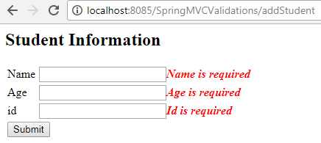

Spring MVC – File Upload
- Project Structure:
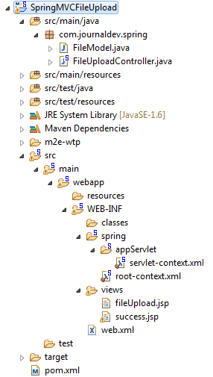
Pom.xml,web.xml and servlet-context.xml are same as SpringMVCExample above
Add below 2 dependencies in pom.xml
<dependency>
<groupId>commons-fileupload</groupId>
<artifactId>commons-fileupload</artifactId>
<version>1.2.1</version> <!-- makesure correct version here -->
</dependency>
<dependency>
<groupId>commons-io</groupId>
<artifactId>commons-io</artifactId>
<version>2.4</version>
</dependency>

- FileModel.java:
package com.journaldev.spring;

import org.springframework.web.multipart.MultipartFile;

public class FileModel {
private MultipartFile file;

public MultipartFile getFile() {
return file;
}

public void setFile(MultipartFile file) {
this.file = file;
}
}

- FileUploadController.java:
package com.journaldev.spring;

import java.io.File;
import java.io.IOException;
import javax.servlet.ServletContext;
import org.springframework.beans.factory.annotation.Autowired;
import org.springframework.stereotype.Controller;
import org.springframework.ui.ModelMap;
import org.springframework.util.FileCopyUtils;
import org.springframework.validation.BindingResult;
import org.springframework.validation.annotation.Validated;
import org.springframework.web.bind.annotation.RequestMapping;
import org.springframework.web.bind.annotation.RequestMethod;
import org.springframework.web.multipart.MultipartFile;
import org.springframework.web.servlet.ModelAndView;

@Controller
public class FileUploadController {

@Autowired
ServletContext context;

@RequestMapping(value = "/fileUploadPage", method = RequestMethod.GET)
public ModelAndView fileUploadPage() {
FileModel file = new FileModel();
ModelAndView modelAndView = new ModelAndView("fileUpload", "command", file);
return modelAndView;
}

@RequestMapping(value="/fileUploadPage", method = RequestMethod.POST)
public String fileUpload(@Validated FileModel file, BindingResult result, ModelMap model) throws IOException {
if (result.hasErrors()) {
System.out.println("validation errors");
return "fileUploadPage";
} else {
System.out.println("Fetching file");
MultipartFile multipartFile = file.getFile();
String uploadPath = context.getRealPath("") + File.separator + "temp" + File.separator;
//Now do something with file...
FileCopyUtils.copy(file.getFile().getBytes(), new File(uploadPath+file.getFile().getOriginalFilename()));
String fileName = multipartFile.getOriginalFilename();
model.addAttribute("fileName", fileName);
return "success";
}
}
}
- fileUpload.jsp:
<%@ page contentType="text/html; charset = UTF-8" %>
<%@ taglib prefix = "form" uri = "http://www.springframework.org/tags/form"%>
<html>
<head>
<title>File Upload Example</title>
</head>

<body>
<form:form method = "POST" modelAttribute = "fileUpload"
enctype = "multipart/form-data">
Please select a file to upload :
<input type = "file" name = "file" />
<input type = "submit" value = "upload" />
</form:form>
</body>
</html>
- Success.jsp:
<%@ page contentType = "text/html; charset = UTF-8" %>
<html>
<head>
<title>File Upload Example</title>
</head>
<body>
FileName :
lt;b> ${fileName} </b> - Uploaded Successfully.
</body>
</html>

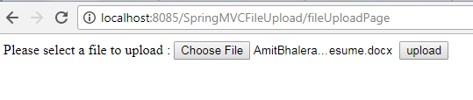
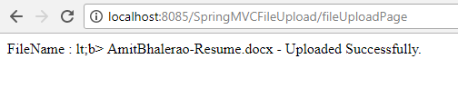

Handler Mapping:
- BeanNameUrlHandlerMapping
- DefaultAnnotationHandlerMapping
- ControllerBeanNameHandlerMapping
- ControllerClassNameHandlerMapping
- SimpleUrlHandlerMapping
- RequestMappingHandlerMapping
  - BeanNameUrlHandlerMapping

HelloController.java
package com.tutorialspoint;
import javax.servlet.http.HttpServletRequest;
import javax.servlet.http.HttpServletResponse;
import org.springframework.web.servlet.ModelAndView;
import org.springframework.web.servlet.mvc.AbstractController;
public class HelloController extends AbstractController{
@Override
protected ModelAndView handleRequestInternal(HttpServletRequest request,
HttpServletResponse response) throws Exception {
ModelAndView model = new ModelAndView("hello");
model.addObject("message", "Hello World!");
return model;
}
}

WelcomeController.java
package com.tutorialspoint;
import javax.servlet.http.HttpServletRequest;
import javax.servlet.http.HttpServletResponse;
import org.springframework.web.servlet.ModelAndView;
import org.springframework.web.servlet.mvc.AbstractController;
public class WelcomeController extends AbstractController{
@Override
protected ModelAndView handleRequestInternal(HttpServletRequest request,
HttpServletResponse response) throws Exception {
ModelAndView model = new ModelAndView("welcome");
model.addObject("message", "Welcome!");
return model;
}
}

servlet-context.xml
<beans xmlns = "http://www.springframework.org/schema/beans"
xmlns:context = "http://www.springframework.org/schema/context"
xmlns:xsi = "http://www.w3.org/2001/XMLSchema-instance"
xsi:schemaLocation = "
http://www.springframework.org/schema/beans
http://www.springframework.org/schema/beans/spring-beans-3.0.xsd
http://www.springframework.org/schema/context
http://www.springframework.org/schema/context/spring-context-3.0.xsd">
<bean class = "org.springframework.web.servlet.view.InternalResourceViewResolver">
<property name = "prefix" value = "/WEB-INF/jsp/"/>
<property name = "suffix" value = ".jsp"/>
</bean>
<bean class = org.springframework.web.servlet.handler.BeanNameUrlHandlerMapping"/>
<bean name = "/helloWorld.htm" class = "com.tutorialspoint.HelloController" />
<bean name = "/hello*" class = "com.tutorialspoint.HelloController" />
<bean name = "/welcome.htm" class = "com.tutorialspoint.WelcomeController"/>
</beans>

hello.jsp
<%@ page contentType = "text/html; charset = UTF-8" %>
<html>
<head><title>Hello World</title>
</head>
<body>
<h2>${message}</h2>
</body>
</html>

welcome.jsp
<%@ page contentType = "text/html; charset = UTF-8" %>
<html>
<head>
<title>Welcome</title>
</head>
<body>
<h2>${message}</h2>
</body>
</html>
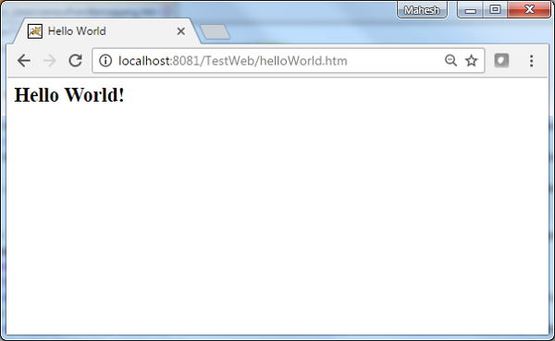
Try a URL − http://localhost:8080/TestWeb/hello.htm and we will see the following screen, if everything is fine with the Spring Web Application.
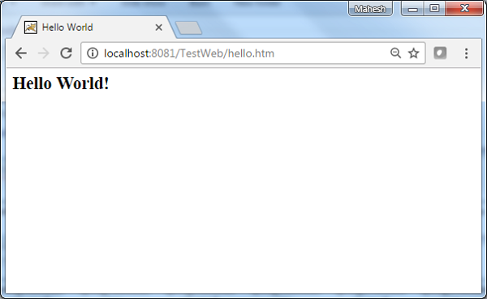
Try a URL http://localhost:8080/TestWeb/welcome.htm and we will see the following screen, if everything is fine with the Spring Web Application.
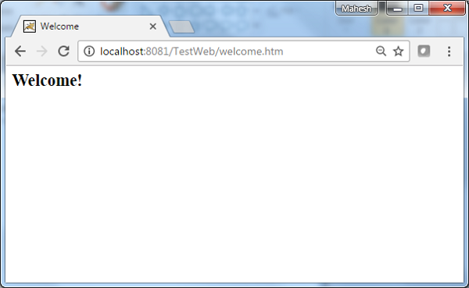
Try a URL http://localhost:8080/TestWeb/welcome1.htm and we will see the following screen, if everything is fine with the Spring Web Application.
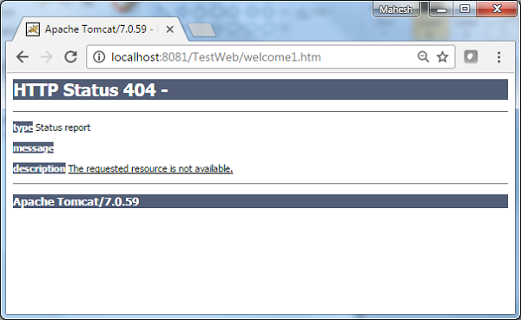
  - ControllerClassNameHandlerMapping:
<beans>
<bean class="org.springframework.web.servlet.view.InternalResourceViewResolver">
<property name = "prefix" value = "/WEB-INF/jsp/"/>
<property name = "suffix" value = ".jsp"/>
</bean>
<bean class = "org.springframework.web.servlet.mvc.support.ControllerClassNameHandlerMapping"/>
<bean class = "com.tutorialspoint.HelloController" />
<bean class = "com.tutorialspoint.WelcomeController"/>
</beans>
For example, using above configuration, if URI
- /helloWorld.htm or /hello{any letter}.htm is requested, DispatcherServlet will forward the request to the HelloController.
- /welcome.htm is requested, DispatcherServlet will forward the request to the WelcomeController.
- /Welcome.htm is requested where W is capital cased, DispatcherServlet will not find any controller and the server will throw 404 status error.
  - SimpleUrlHandlerMapping:
The SimpleUrlHandlerMapping class helps to explicitly-map URLs with their controllers respectively.
<beans>
<bean class = "org.springframework.web.servlet.view.InternalResourceViewResolver">
<property name = "prefix" value = "/WEB-INF/jsp/"/>
<property name = "suffix" value = ".jsp"/>
</bean>
<bean class = "org.springframework.web.servlet.handler.SimpleUrlHandlerMapping">
<property name = "mappings">
<props>
<prop key = "/welcome.htm">welcomeController</prop>
<prop key = "/helloWorld.htm">helloController</prop>
</props>
</property>
</bean>
<bean id = "helloController" class = "com.tutorialspoint.HelloController" />
<bean id = "welcomeController" class = "com.tutorialspoint.WelcomeController"/>
</beans>
For example, using above configuration, if URI
- /helloWorld.htm is requested, DispatcherServlet will forward the request to the HelloController.
- /welcome.htm is requested, DispatcherServlet will forward the request to the WelcomeController.

Controllers:
- SimpleFormController
- AbstractController
- AbstractCommandController
- CancellableFormController
- AbstractCommandController
- MultiActionController
- ParameterizableViewController
- ServletForwardingController
- ServletWrappingController
- UrlFilenameViewController
- AbstractController
- AbstractCommandController
- SimpleFormController
- CancellableFormController.
